

TRIBHUVAN UNIVERSITY

INSTITUTE OF SCIENCE AND TECHNOLOGY

A Project Proposal Report

On

**Edusense Learning AI Agent**

**Submitted to:**

Department of IT

Hetauda City College

*In partial fulfillment of the requirements for Bachelors of Science in Computer Science and Information Technology*

**Submitted By**:

**Rabin Glan** (29876/078)

**Shishir Kumar Bartaula** (29879/078)

May 2025

**Table of Contents**

**Title Page**   **i** **Table of content   ii**

**List Of Figures iii**

**1. Introduction** 1

**2. Problem Statement** 2

**3. Objectives** 3

**4. Methodology** 4

**4.1. Requirement Identification** 4

**4.1.1.** Study of Existing System 4

**4.1.2.** Requirement Analysis 4

**4.2. Feasibility Study** 5

**4.2.1.** Technical Feasibility 5

**4.2.2.** Operational Feasibility 5

**4.2.3.** Economic Feasibility 5

**4.2.4.** Schedule (Gantt chart showing the project timeline) 6

**4.3. System Design** 7

**4.3.1.** Methodology 7

**4.3.2**. Flowchart 8

**4.3.3.** Description Of Algorithm…………………………………………………………...9

**6. Expected Outcomes** 9

**7. REFERENCES** 10

**List of Figures**

Figure 1: Gantt Chart 6

Figure 2: Agile Model 7

Figure 3: Flowchart 8

# **1. Introduction**

Edusense AI is a web-based learning platform that leverages artificial intelligence to deliver personalized educational experiences. It allows users to upload their own study materials, interact with a conversational AI tutor, visualize complex concepts, take notes, and track their progress — all within a single environment.

By integrating large language models like Llama 3, Mistral, and Mixtral, the system provides context-aware assistance directly tied to the user's content. This approach addresses the limitations of traditional learning methods by adapting to individual learning styles and needs. Edusense AI is designed to support students, educators, self-learners, and professionals, offering a flexible and intelligent tool for modern education.

# **2. Problem Statement**

Despite ongoing advancements in educational technology, learners still face several persistent challenges:

* **Information Overload:** Students are often overwhelmed by vast amounts of content, with limited tools to organize, process, or understand how concepts are connected.
* **Lack of Personalization:** Most learning platforms provide uniform content, failing to adapt to individual learning styles, prior knowledge, or specific needs.
* **Limited Access to Expert Support:** Many learners do not have reliable access to experts who can clarify doubts or provide tailored guidance.
* **Poor Knowledge Organization:** Information is frequently presented in linear formats, which don’t reflect the interconnected nature of real-world knowledge.
* **Difficulty Tracking Progress:** Learners struggle to evaluate their understanding and identify areas that need improvement.
* **Passive Learning:** Many digital tools focus on content delivery rather than encouraging active engagement or interaction.
* **Fragmented Tools:** Educational resources are often spread across multiple disconnected applications, disrupting the learning flow.
* **Lack of Contextual Understanding:** Most AI-driven tools provide generic answers without considering the learner’s specific materials or context.

Edusense AI addresses these issues by offering a unified, AI-powered platform that combines personalized tutoring, knowledge visualization, and progress tracking. The goal is to create an engaging, adaptive, and context-aware learning experience tailored to everyone’s journey.

# **3. Objectives**

The primary goal of this project is to develop EduSense AI, an AI-powered learning platform that delivers personalized tutoring, intuitive knowledge visualization, and effective progress tracking. To achieve this, the project sets the following specific objectives:

* To enable users to upload a range of file types (PDF, DOCX, TXT).
* To provide accurate, context-aware answers grounded in user documents.
* To adapt explanations to different learning styles and levels.
* To support visual learners through dynamic, engaging representations.
* To reveal relationships between key concepts for deeper insight.
* To offer integrated note-taking tools linked directly to study materials.
* To protect all user data and uploaded content with robust security controls.

# **4. Methodology**

## **4.1. Requirement Identification**

### **4.1.1. Study of Existing System**

### A review of current e-learning platforms and AI-driven tutoring systems reveals several limitations. While platforms like Coursera, Khan Academy, and traditional LMS solutions offer access to structured learning content, they often lack personalized learning experiences, contextual assistance, and integrated tools for progress tracking. Similarly, existing AI-based tools such as ChatGPT or intelligent tutoring systems provide general assistance but fail to adapt to user-uploaded content or support active, visually driven learning. Edusense AI aims to bridge these gaps by offering a unified, intelligent learning platform that combines AI-powered tutoring, document-based learning, knowledge visualization, and learning analytics.

### **4.1.2. Requirement Analysis**

To design a robust, user-centered learning platform, an in-depth understanding of end-user needs was conducted. The key identified requirements include:

* Uploading and processing of user-provided documents (PDF, DOCX, TXT).
* Real-time, context-aware tutoring using open-source LLMs (Llama, Mistral, etc.).
* Natural language Q&A with context retention.
* Tools for notetaking, progress tracking, and knowledge assessment.
* A responsive, accessible, and intuitive user interface.
* Scalable and secure architecture that ensures data privacy and future extensibility.

## **4.2. Feasibility Study**

### **4.2.1. Technical Feasibility**

The proposed system will be developed using modern and robust technologies:

**Frontend**: Next.js, Tailwind CSS, TypeScript, shadcn/UI

**Backend**: Next.js API Route, MongoDB, Vector Database, LangChain, LangGraph

**AI Component:** LLMs, Ollama, Embedding Models (BGE, Nomic Embed), Hugging Face Transformers

These technologies are well-documented, have large community support, and are suitable for building a scalable web application. The development team possesses the necessary skills and resources to work with this technology stack, ensuring the technical feasibility of the project.

### **4.2.2. Operational Feasibility**

The Edusense system is designed to be a web-based platform, accessible through standard web browsers on various devices and will require minimal technical expertise from users.

### **4.2.3. Economic Feasibility**

The project aims to be economically viable through the utilization of open-source technologies and potentially cost-effective hosting solutions.

* **Software Costs:** React, .NET, PostgreSQL and AI models are all open-source and free to use, significantly reducing software licensing costs.
* **Development Costs:** The primary economic investment will be in the development effort, which includes design, coding, testing, and deployment.

### **4.2.4. Schedule (Gantt chart showing the project timeline)**

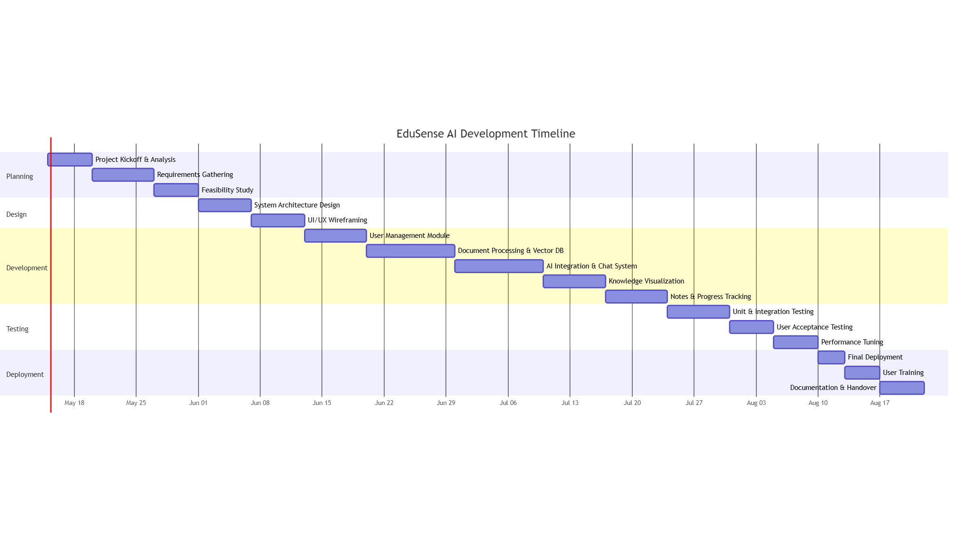

Figure 1: Gantt Char

## **4.3. System Design**

### **4.3.1. Methodology**

EduSense AI will adopt the Agile methodology using a lightweight Scrum framework, well-suited for a two-developer academic team. This ensures flexibility, quick iteration, and adaptability to evolving requirements.

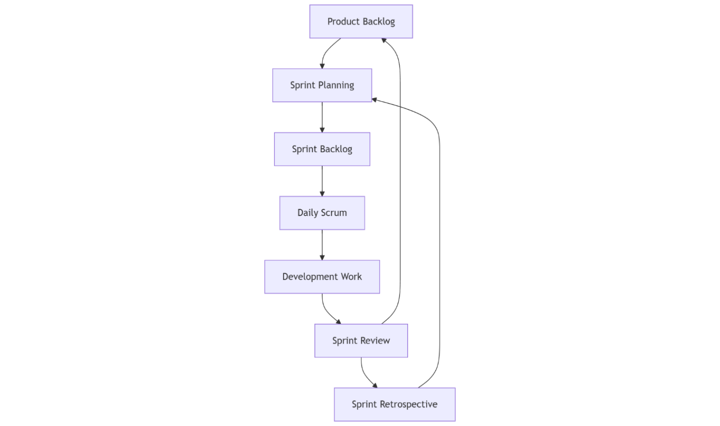

Figure 2: Agile Model

### **4.3.2. Flowchart**

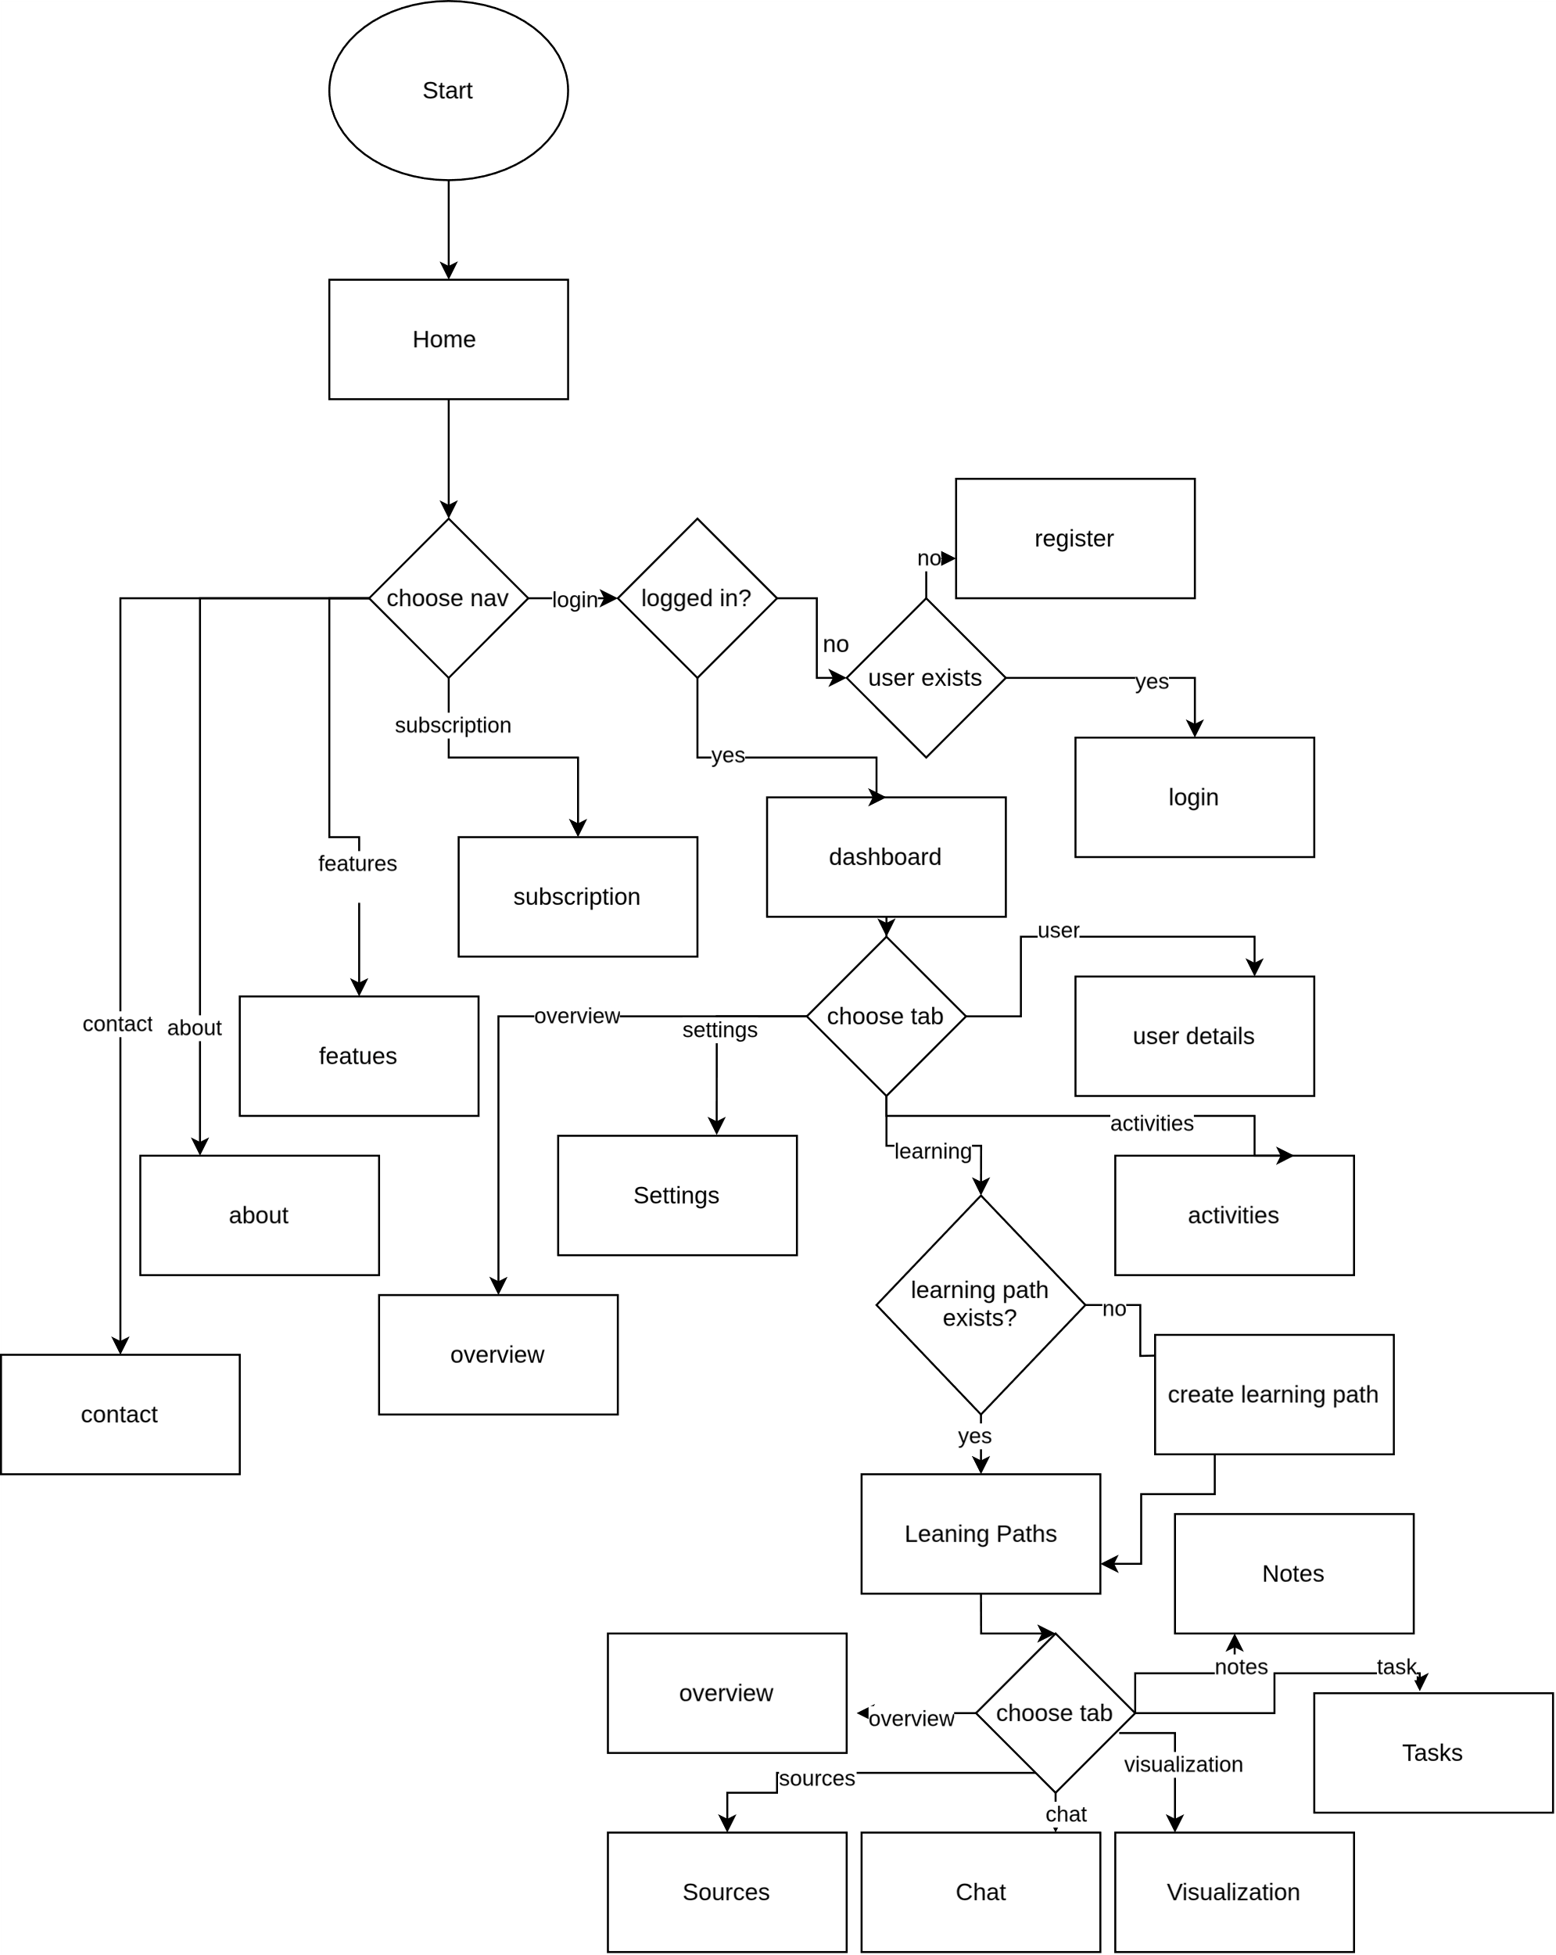

Figure 3: Flowchart

**4.3.3 Description of Algorithm**

**Document Chunking Algorithm**

Purpose: To split the document into overlapping chunks so that the semantic context is preserved across boundaries, improving embedding quality.

Details:

Use a fixed chunk size (e.g., 500 tokens/characters) with an overlap (e.g., 100 tokens) to slide over the document text.

This reduces the chance of losing important contextual links between segments.

**Embedding Generation Algorithm**

Purpose: To convert each text chunk into a vector representation that captures semantic meaning.

Details:

Use OpenAI’s embedding API (text-embedding-ada-002) to encode chunks.

Store embeddings as float vectors in the vector database.

**Vector Retrieval Algorithm**

Purpose: To retrieve the most relevant chunks given a user query.

Details:

Embed the user query using the same embedding model.

Perform similarity search (cosine similarity or Euclidean distance) in the vector database.

Retrieve top-k chunks (e.g., k=5).

**RAG Pipeline**

Purpose: To generate a natural language response to the user query using retrieved document context.

Details:

Construct prompt with system instructions and user query plus retrieved content.

Use GPT-4 or similar LLM to produce coherent and context-aware answers.

**Visualization Generation**

Purpose: Convert AI-generated data into interactive visual formats like mind maps and timelines.

Details:

Use Mermaid.js or D3.js to render graph and timeline visualizations.

Parse AI output to identify nodes and relationships.

**Fine Tuning algorithm: LoRA and QLoRa algorithms**

Purpose: adapt large language models efficiently by updating only a small number of parameters, reducing memory and computational requirements without sacrificing performance**.**

Details:

It fine-tunes large language models by injecting small, trainable rank decomposition matrices into the model's layers

QLoRA extends LoRA by applying quantization (e.g., 4-bit precision) to reduce memory usage even further.

# **6. Expected Outcomes**

The successful implementation of EduSense AI is expected to deliver measurable benefits across learners, educators, and the system's technical performance. The outcomes are categorized as follows:

1. **For Learners**

* **Personalized Learning**: Learners will receive AI-driven tutoring tailored to their individual needs and preferences, with explanations adapted to different learning styles.
* **Deeper Understanding**: Complex concepts will be simplified through visual representations such as mind maps and knowledge graphs, helping learners grasp interrelated ideas more effectively.

1. **For Educators**

* **Teaching Assistance:** Educators can use the platform to automatically address common student questions and create dynamic visual aids to support their teaching.
* **Enhanced Content Delivery:** Uploaded teaching materials are analyzed and transformed into visual structures, improving clarity and engagement.

**c .** **Technical Outcomes**

* **Functional Platform:** A fully operational and user-friendly web application accessible across devices.
* **AI Integration**: Seamless integration of open-source large language models (LLMs) to provide context-aware responses based on user documents.
* **Secure and Scalable Infrastructure**: The platform will support multiple users simultaneously with strong data protection, modular architecture, and readiness for future expansion.

# **7. REFERENCES**

[1] O. Zawacki-Richter, V. I. Marín, M. Bond, and F. Gouverneur, "Systematic review of research on artificial intelligence applications in higher education – where are the educators?" *International Journal of Educational Technology in Higher Education*, vol. 16, no. 1, pp. 1-27, 2019.

[2] G. J. Hwang, P. H. Wu, and H. R. Chen, "An online game approach for improving students’ learning performance in web-based problem-solving activities," *Computers & Education*, vol. 59, no. 4, pp. 1246-1256, 2012.

[3] P. Liu, W. Yuan, J. Fu, Z. Jiang, H. Hayashi, and G. Neubig, "Pre-train, prompt, and predict: A systematic survey of prompting methods in natural language processing," *ACM Computing Surveys*, vol. 55, no. 9, pp. 1-35, 2023.

[4] W. Holmes, M. Bialik, and C. Fadel, "Artificial intelligence in education: Promises and implications for teaching and learning," Center for Curriculum Redesign, Boston, MA, 2019.

[5] B. J. Zimmerman and D. H. Schunk, *Self-regulated learning and academic achievement: Theoretical perspectives*, Routledge, 2001.